**Advertisement:**

Primary Health Centre Phullena thawk tur IPA hnuaiah Office Assistant lak a ni dawn a. Dil duhte chuan a hnuaia hun leh hmun ruatah Interview neih tur a ni ang. Hrechiang duh chuan Phullen PHC ah office hour ah englai pawhin zawh fiah theih reng a ni e.

Date of Interview : 10/07/2023 (Monday)

Venue : Main Centre, Phullen PHC

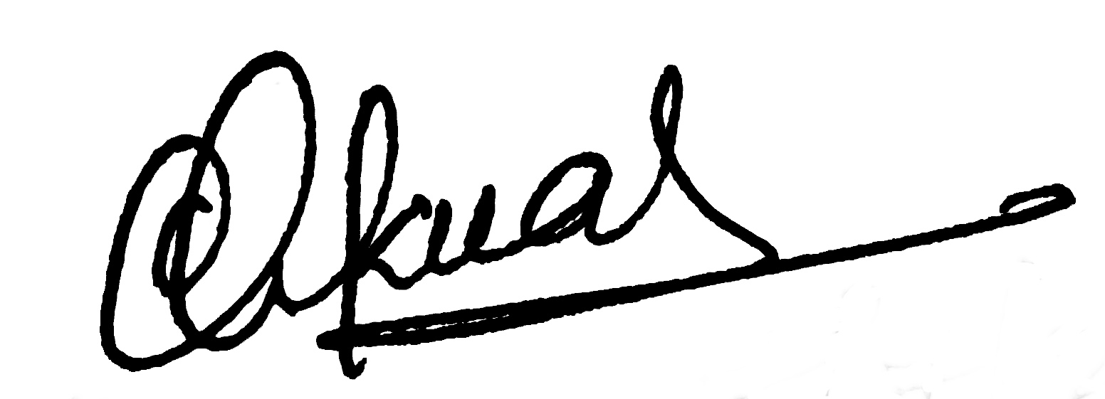

(Dr.LALCHHANCHHUAHI)

Medical Officer

Phullen PHC